1.屏蔽添加删除tray操作

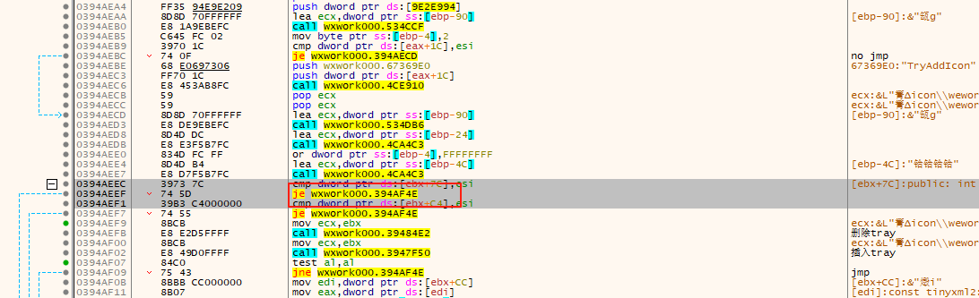

3973??745D39B3????????

3973??EB...

2.修改tray更新操作的结构体

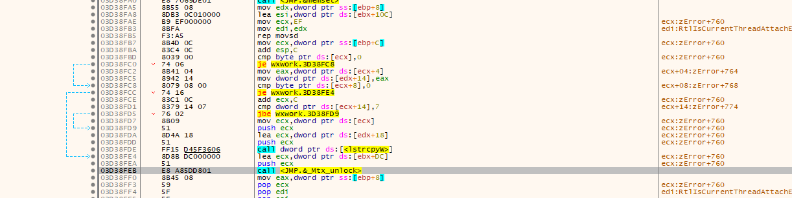

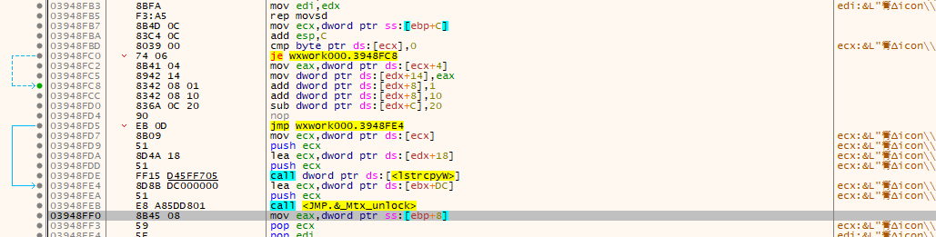

Uid->add10+num

Chageuflag7->7

80790800741683C10C837914077602

834208{num_u8}83420810836A0C2090EB0D

3.程序唤起

Tencent.WeWork.ActivateApplication

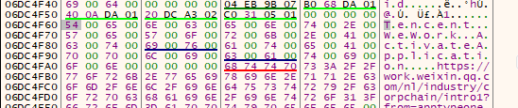

540065006E00630065006E0074002E005700650057006F0072006B002E00410063007400690076006100740065004100700070006C00690063006100740069006F006E

...{num}

4.Mutex

Tencent.WeWork.ExclusiveObject

->

Tencent.WeWork.ExclusiveObjec{num}

540065006E00630065006E0074002E005700650057006F0072006B002E004500780063006C00750073006900760065004F0062006A006500630074

5.账号相关

Config.cfg 多个

436F6E6669672E636667

43006F006E006600690067002E006300660067

config.db多个

636F6E6669672E6462

corp_logo多个

63006F00720070005F006C006F0067006F

636F72705F6C6F676F

qrcode_login_user_avator

7172636F64655F6C6F67696E5F757365725F617661746F72

httpdns.cfg

68747470646E732E636667